Basic of GenAI

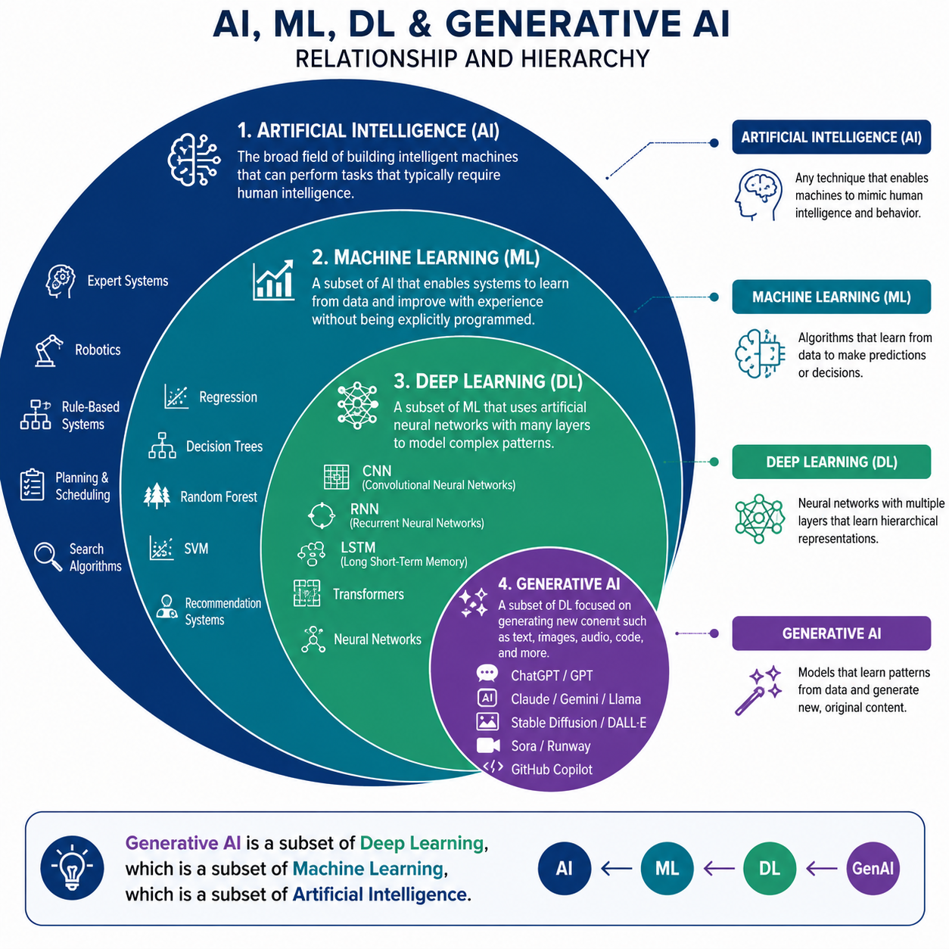

How models get trained
- Key points
- Models trained on huge dataset
- Preprocessing required like formatting and cleaning
- Data need to convert into required format
- Need huge GPUS
- Model Evlaution techniques
- Model deployment at Data centers.
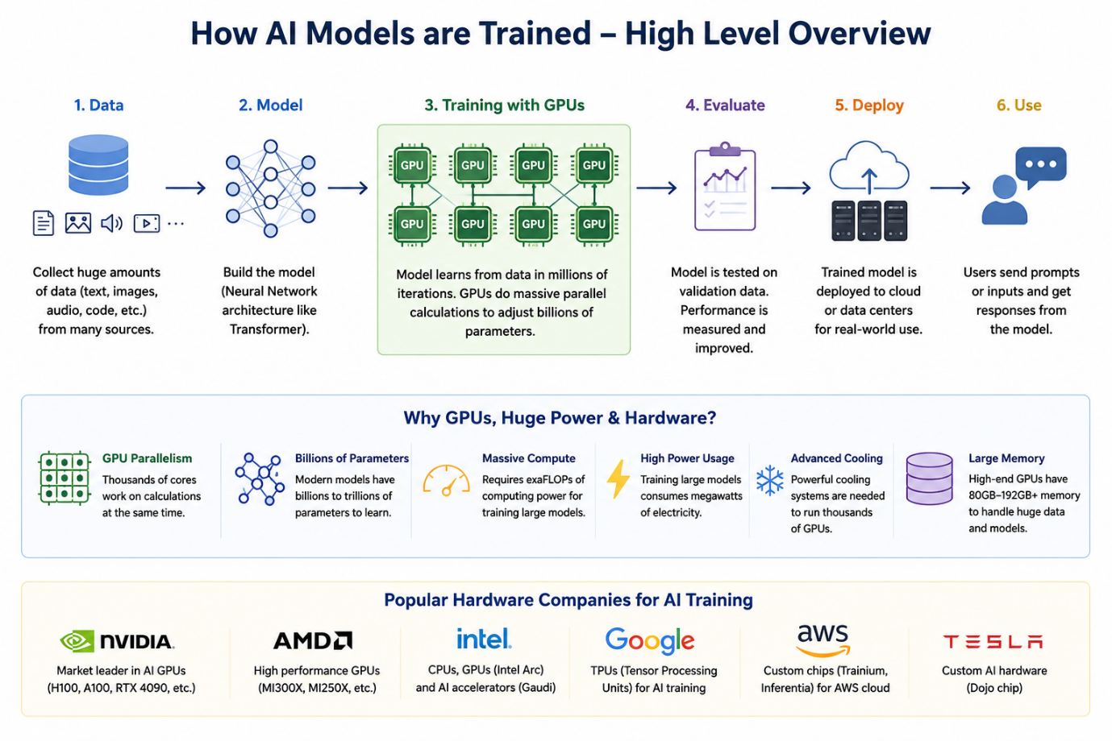

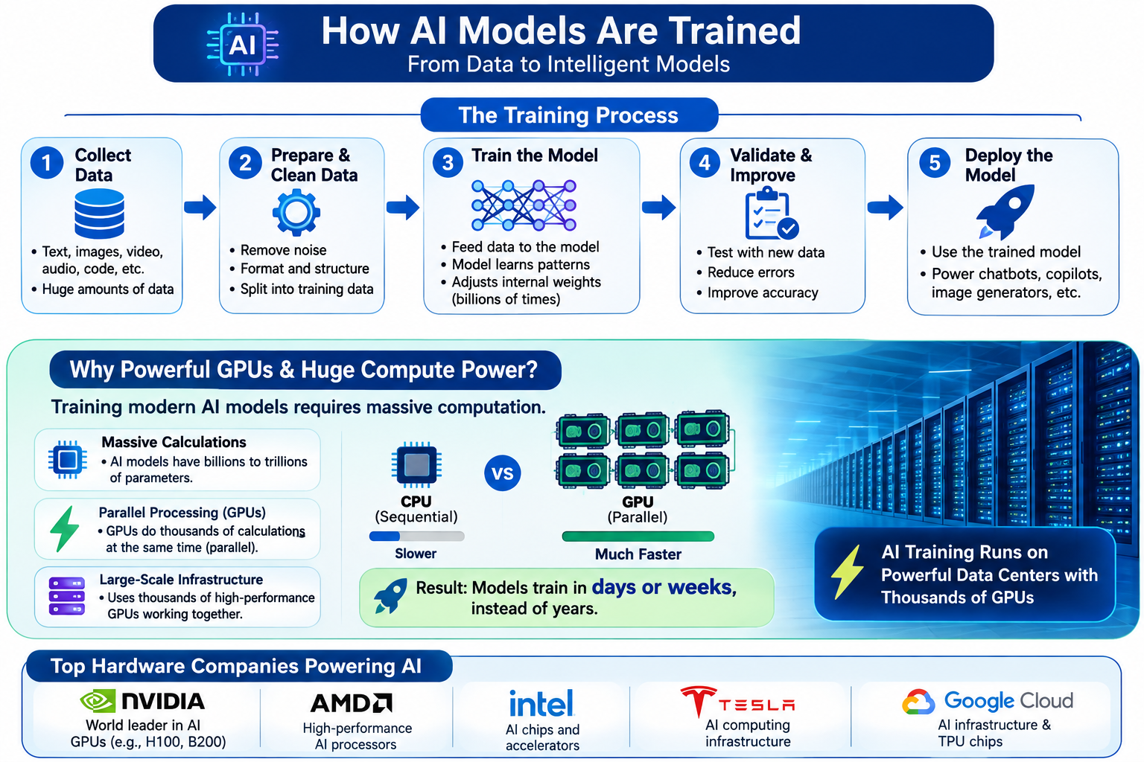

Self Attention and Postion encoding

